Accreditation Planner
Suggestions for Charting the Journey

“A journey of a thousand miles begins with a single step”
Lao-tzu, The Way of Lao-tzu
Chinese philosopher (604 BC – 531 BC)

Getting Started: Gathering supplies and resources

- Garner Board/Governing body support and approval

- Identify an accreditation coordinator to lead the effort

- Determine how and when to announce the journey to staff

- Ask the accreditation coordinator to set aside 90 minutes to quickly review Standards and Measures, and examples of supporting documents to identify activities the organization is presently doing and to list development that needs to occur

- Based on review, set a goal date when the organization will be ready for accreditation

- Determine which method the accreditation coordinator will use to gather the necessary documentation
  - Work alone collecting the information from others
  - Establish a committee and divide the work up among its members
  - Establish several teams each addressing 2-3 of the Ten Essential Services
  - Hire a consultant to guide the process

- Determine how and when the work of gathering documentation will be done
  - Ask staff to incorporate it into their present work load
  - Block one morning or afternoon per week/month for staff to gather documentation
  - Create time in conjunction with other regularly scheduled meetings

- Consider ways to make the accreditation journey a fun, challenging, team building process for staff and/or board and/or community members

Getting Going: Kicking off the Journey

- Establish a filing system to collect materials (data, reports, committee minutes, etc.) that provide evidence of fulfillment of performance measures; or reference where such materials are located in the agency (example: policy manuals, etc.). It would be helpful to mirror the DropBox filing structure sent to you once your application and fees have been accepted by MICH
  - Contact other agencies that have completed their accreditation journey to see how they organized their documents

- Set a journey “kick off” date with staff and governing body officials
  - Announce your goal date for accreditation
  - Describe staff roles in the process
  - Describe who and how documentation of the performance measures will be organized
  - Keep the process fun and flexible

- Establish a regular communication channel to keep staff updated and informed about the process and the progress your agency is making

- If a committee or teams have been established, utilize them to complete performance indicators that are in progress

Getting Along: Keeping the momentum

- Identify the staff member(s) or program most appropriate to provide documentation of each performance indicator

- Develop a tracking mechanism for documents to be collected
  - Provide links to resources or share the Accreditation Worksheets
  - Create a master log book/notebook: Place the standards in the notebook; initial each performance measure with staff assigned; check mark and date each performance indicator when assembly of documentation is completed

- Have the accreditation coordinator follow up with staff or program documentation assignments. The coordinator should communicate with staff members on a regular basis to ensure they are working on or have submitted the requested documentation.

- To keep track of the documentation collected or that still needs to be collected, develop a checklist/cover sheet for each performance measure. MICH has created an Accreditation Worksheet that can be used.

- If staff is uncertain regarding a performance measure, or adequacy of documentation, call or e-mail MICH with questions.

- If a performance measure is encountered for which there are no processes in place, don’t panic! Utilize the wisdom of those who have completed the accreditation journey before you. Call an accredited agency of similar size and ask how the performance indicator was accomplished and/or documented. If necessary, be flexible and adjust your site review date.

- If your organization tried to accomplish a particular performance measure and has been unsuccessful, document the efforts (why it isn’t being done, and the barriers that have made it difficult). Additionally, contact MICH for suggestions as to how to document or approach the situation. (Remember that there are allowances in the scoring for a few “not mets”.

- Monthly or quarterly, sit down with your planning group/committee and review:
  - The documentation you’ve collected to assure it supports the intent of the standard
  - The documentation that has not been collected
  - The performance indicators and or measures that the agency is not yet able to demonstrate, and for which processes /policy needs to be developed

- Regardless of how fast or slow the progress, keep the process of accreditation fun and flexible.

- To keep accreditation on the front burner for staff and board, communicate progress regularly emphasizing the positive things that are accomplished, learned, or created as a result of the journey

- Keep a list of all the improvements the agency makes along the way, whether in processes, in staff professional development, policy development, etc. It will be a source of pride to look back at how far the agency has progressed.

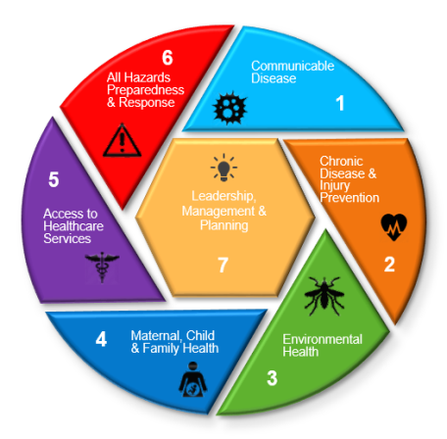
Getting There: Arriving at your destination

- If not previously scheduled, work with MICH to establish dates for the site visit

- Review the documentation collected for each performance measure to ensure what has been collected adequately demonstrates performance of indicators and measures, most measures require 2 examples unless stated otherwise

- If there are questions regarding the adequacy of documentation, contact MICH or an accredited agency to gather their insights

- Complete and submit the Excel Standards Workbook to MICH

- Work with MICH staff to plan the site visit agenda. Invite board and/or governing body officials and staff to hear the reviewers’ preliminary findings. Consider asking a staff member to take notes

- Prepare staff for the site visit. Review the purpose and the benefits of the accreditation process

- Identify who will answer questions and serve as the liaison between the agency and the MICH Reviewers during the site visit

- Reserve and prepare a room for the site visit

- Clean the facility

- Invite board/governing body and key staff to the opening meeting with the MICH Reviewers

Getting Back: The celebration and incorporating accreditation into day-to-day operations

- Congratulate yourself, staff and key partners in completing the accreditation process

- Document the agency’s journey of planning, organizing, and completing the accreditation process

- Safely organize and store documentation

- Decide how the agency will celebrate if accredited

- Review Excel Workbook with the Reviewers, Accreditation Council and MICH Board member comments with key staff and partners.

- Celebrate the strengths identified in the Workbook

- Within 3 months complete the Annual Report, Year 1, a five-year Performance Improvement Plan to address the “Not Mets” and “Opportunities for Improvement” listed in the Workbook. Search online at the MICH website, NACCHO, Public Health Foundation, CDC, etc. or contact accredited agencies to generate ideas on how to improve the areas selected

- Develop a routine to keep accreditation alive in the agency and in the forefront when planning new initiatives

- Visit the MICH web site often to stay abreast of the accreditation process in Missouri

- Consider volunteering to be a reviewer or serving on one of the MICH committees to assist other agencies in the accreditation journey

